


ASSIGNMENT

LEVEL 4

COMP40002 : Networking Concepts and Cyber
Security 1

Group Assessment: COM24A2

Sandakan Mandara Liyanage (Leader) | CB01456
Ganidu Sasmitha | CB014572
Ryan Gamalathge | CB014647

Acknowledgement
We greatly appreciate Mr. Tharaka Dulaj's essential support with this project. His knowledgeable advice and constant support were crucial to its successful completion.

Content
1. Introduction 7
2. Topology 8
2.1. Network Topology 8
2.1.1 Star Topology 8
2.1.1.1 Reasons for using Star Topology 8
2.1.1.2 Advantages of Star Topology 9
2.1.2 Bus Topology 10
2.1.2.1 Reasons for using Bus Topology 10
2.1.2.2 Advantages of Bus Topology 10
2.1.3 Tree Topology 11
2.1.3.1 Reasons for using Tree Topology 11
2.1.3.2 Advantages of Tree Topology 11
2.1.4 Mesh Topology 11
2.1.4.1 Reasons for using Mech Topology 12
2.1.4.2 Advantages of Mech Topology 12
2.2. Structured Framework 12
2.3.1 Layer 1 (Internal Layer) 13
2.3.1.1 Core Layer 13
2.3.1.2 Distribution Layer 13
2.3.1.3 Access Layer 13
2.3.2 Layer 2 (Data Link Layer) 13
2.3.2.1 Ethernet 14
2.3.2.2 VLAN 14
2.3.3 Layer 3 (Network Layer) 14
2.3.3.1 IP (Internet Protocol) 14
2.3.3.2 Routing 14
2.3.3.3 NAT (Network Address Translation) 15
3. Tools of Choice 15
3.1. Routers 15
3.1.1 Cisco ISR 4331 15
3.1.1.2 Advantages of Cisco ISR 4331 16
3.1.1.3 Disadvantages of Cisco ISR 4331 16
3.1.2 Cisco ISR 4321 16
3.1.2.1 Advantages of Cisco ISR 4321 17
3.1.2.2 Disadvantages of Cisco ISR 4321 17
3.1.3 Cisco 1941/K9 17
3.1.3.1 Advantages of Cisco 1941/K9 18
3.1.3.2 Disadvantages of Cisco 1941/K9 18
3.2. Switches 19
3.3.1 Cisco Switch Catalyst 3650 19
3.3.1.1 Advantages of Cisco Switch Catalyst 3650 19
3.3.1.2 Disadvantages of Cisco Switch Catalyst 3650 20
3.3.2 Cisco WS-C2960+24PC-S Switch 20
3.3.2.1 Advantages of Cisco WS-C2960+24PC-S Switch 20
3.3.2.2 Disadvantages of Cisco WS-C2960+24PC-S Switch 21
4. Identifying and Addressing Security Vulnerabilities 22
4.1. Switch Port Security 22
4.2.1 Key Features 22
5. References 25
6. APPENDIX A- VLSM Plan & Topology 28
6.1. VLSM Plan 28
6.2. Topology 29
7. Configurations 33
7.1. Vlanning 33
7.2. IP Routing 35
7.3. WAN 35
7.4. HSRP 36
7.5. NAT 37
7.6. Switch Port Security 38
7.7. Redundancy 41

Table of Figures

Figure 1: Example design of the APIIT’s Network Infrastructure. 7
Figure 2: Simple Star Topology of our sketched design. 9
Figure 3: Multi-star Topology of our sketched design. 9
Figure 4: Bus Topology of our sketched design. 10
Figure 5: Tree Topology of our sketched design. 11
Figure 6: Partly Mesh Topology of our sketched design. 12
Figure 7: Structured Framework of our sketched design. 13
Figure 8: Cisco 4331 Integrated Services Router. 15
Figure 9: Cisco 4321 Integrated Services Router. 16
Figure 10: CISCO1941/K9 Cisco 1941 Router ISR G2. 17
Figure 11: Cisco Switch Catalyst 3650. 19
Figure 12: Cisco WS-C2960+24PC-S Switch. 20
Figure 13: Screenshot of a VLSM of the Main Campus 28
Figure 14: Screenshot of a VLSM of the Kandy Branch 28
Figure 15: Screenshot of a VLSM of the R&D 28
Figure 16: The entire Topology. 29
Figure 17: Topology of the Main Campus. 30
Figure 18: Topology of the Kandy Branch. 31
Figure 19: Topology of the R&D. 32
Figure 20: Configuration of a VLAN in the Main Campus. 33
Figure 21: A screenshot of a VLAN brief. 34
Figure 22: A Screenshot of an Enabling IP Routing on the R&D Switch. 35
Figure 23: Configuring Serial Interface on the Main Campus’s Marketing Department Router. 35
Figure 24: Configuring HSRP for High Availability on HQMR router. 36
Figure 25: Configuring HSRP for High Availability on HQRR Router. 36
Figure 26: Configuring NAT on the KDMR Router. 37
Figure 27: A screenshot of an inside NAT interface. 38
Figure 28: A screenshot of an outside NAT interface. 38
Figure 29: A screenshot of a configuring Port Security on the Switch. 38
Figure 30: A screenshot of a verifying Port Security on the Switch. 39
Figure 31: A screenshot of a verifying Port Security on the Switch. 40
Figure 32: Monitoring Redundancy and Failover on Router. 41

List of Tables
Table 1: Comparison of Key Features Across Cisco Routers (Router-switch.com, 2018). 18
Table 2: Comparison of Pros Between Cisco WS-C2960+24PC-S Switch and Cisco Catalyst 3650 (Layer 2 vs. Multilayer Switch) (CISCO, 2018) 21
Table 3: Overview of Switch Port Security Features and Configurations 24

Introduction

This study covers the task of building a network infrastructure to support APIIT's growth across three locations. These locations include the Main Campus, Research and Development, and Branch Kandy. Everybody has different operational needs, which have an impact on the design of the network, the choice of devices, and even the application of technology. The primary objective is to create a safe and effective network infrastructure since it will facilitate effective data management, communication, and numerous other tasks among the three divisions. To address this issue, we will build a network with the following features:
- Subnetting and IP Addressing
- VLANs and Routing Protocols
- Redundancy
- PAT

By taking these actions, we intend to develop a network architecture that is secure and efficient enough to meet APIIT's current and future requirements. This network was designed and configured using Cisco Packet Tracer, and we have tested it multiple times to ensure its flawless operation.
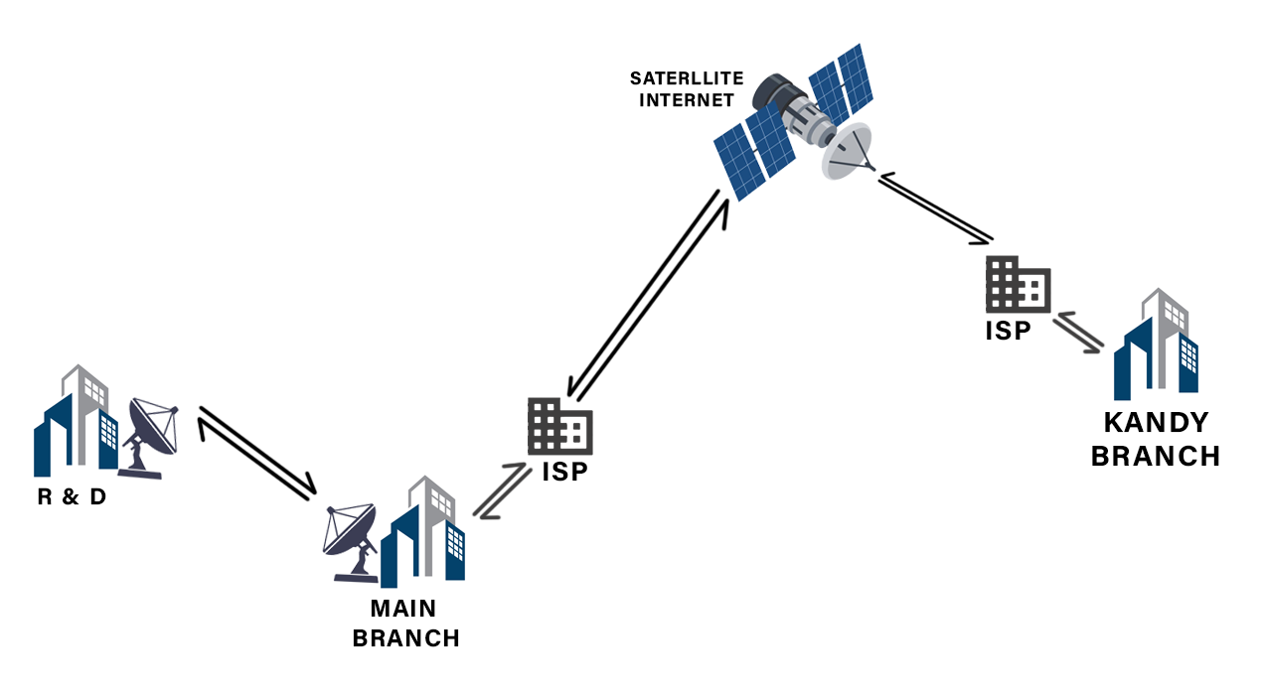
Figure 1: Example design of the APIIT’s Network Infrastructure.

Topology

Network Topology

A network topology is a configuration of several components, referred to as nodes, that are connected to exchange information (Montori, et al., 2018). This document describes the connections and interactions between each of these components. The topologies most frequently employed are:
- Bus Topology
- Star Topology
- Ring Topology
- Mesh Topology
- Hybrid Topology
- Tree Topology

The topology we used in this assignment is Hybrid Topology. Hybrid Topology means two or more topologies combined to form a single topology. It improves flexibility and efficiency by utilizing the strong points of each topology while mitigating their weaknesses. We used:

Star Topology
A device is in a star topology when it is connected to a single hub by cables. This was used at the Main Campus, where a hub switch was used, and a star topology was created by connecting more switches. One of the main advantages of star topology is that it is economical because it uses inexpensive coaxial cable

2.1.1.1 Reasons for using Star Topology
Star topology is reliable and ideal for networks of any size because it provides fault isolation, scalability, high performance, data priority, efficient traffic monitoring, and interoperability with a variety of devices. (Mukherjee, et al., 2019).

2.1.1.2 Advantages of Star Topology
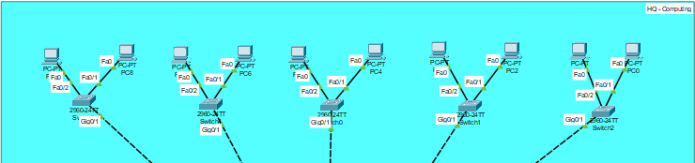
Cost-effective, simple to operate, and flexible enough to accommodate network expansion, star topology improves security through central hub monitoring (GeeksforGeeks, 2024).

Figure 2: Simple Star Topology of our sketched design.
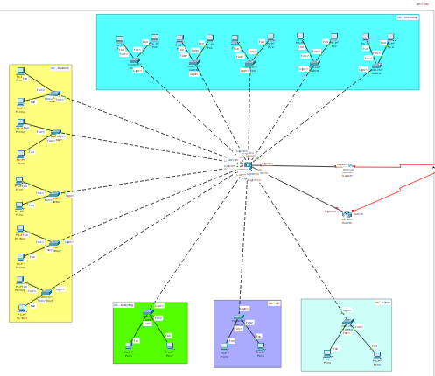

Figure 3: Multi-star Topology of our sketched design.

Bus Topology
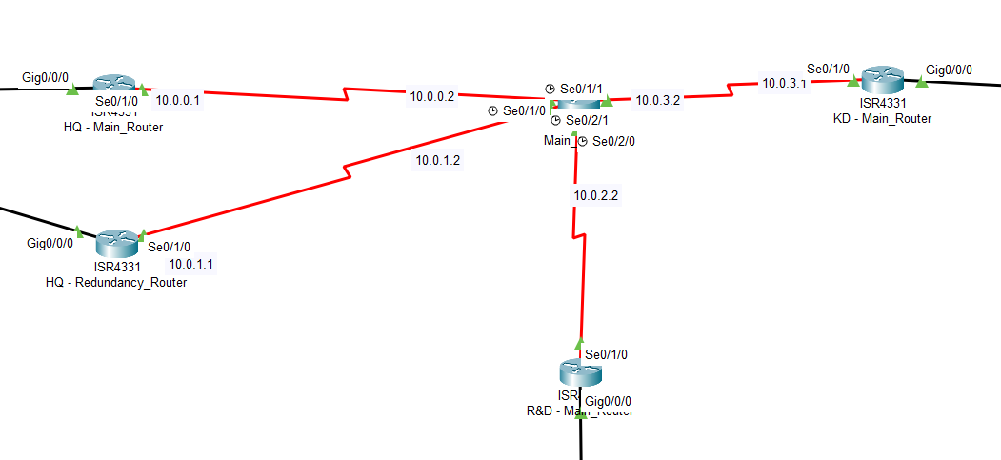
In a bus topology, data is sent over a shared cable, and each node checks whether the destination address (MAC or IP address) matches its own. If the address doesn’t match, the node simply ignores the data. However, if the address matches, the node processes the information accordingly. In a bus topology, a central network cable serves as the primary communication pathway between nodes (GeeksforGeeks, 2024).

Figure 4: Bus Topology of our sketched design.

2.1.2.1 Reasons for using Bus Topology
Using a bus topology in Cisco Packet Tracer is great for beginners, offering easy setup, simple expansion, and an opportunity to learn troubleshooting and basic networking skills.

2.1.2.2 Advantages of Bus Topology
Bus topology's simplicity, affordability, low cabling requirements, and ease of expansion make it an excellent choice for small networks.

Tree Topology
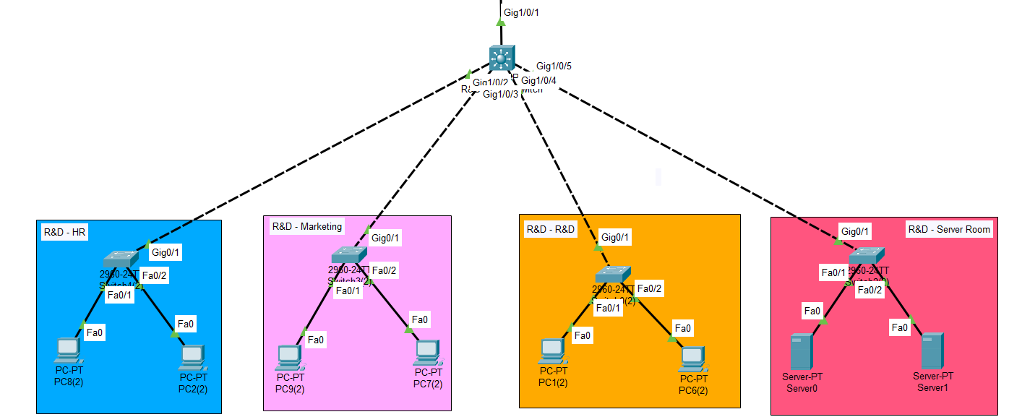
Tree Topology, also known as Hierarchical Topology, is the configuration used when devices re connected hierarchically (GeeksforGeeks, 2024).
Figure 5: Tree Topology of our sketched design.

Reasons for using Tree Topology
Tree topology is scalable and efficient, combining bus and star topologies. It’s ideal for large networks, offering easy management, growth, and improved performance, making it perfect for WANs and complex business networks. (Javapoint, 2025).

Advantages of Tree Topology
Tree topology is perfect for big networks because it provides scalability, effective management, dependability, and a mix of bus and star advantages.

Mesh Topology
In a mesh topology, every network device (also known as a node) is connected to every other device. This ensures that data can travel in numerous ways by creating a structure like a web.
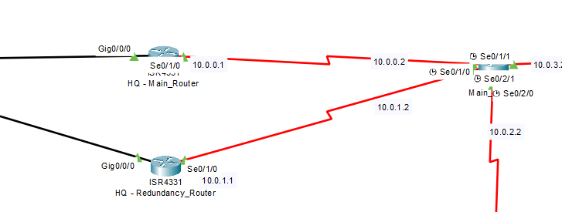
Figure 6: Partly Mesh Topology of our sketched design.

Reasons for using Mech Topology
Mechanical topology optimizes system design for reliability, efficiency, and cost-effectiveness. It reduces energy loss, improves load distribution, and enhances stability while supporting sustainability and customization. Modern technologies like additive manufacturing improve accuracy and design aesthetics. (GeeksforGeeks, 2024).

2.1.4.2 Advantages of Mech Topology
Mesh topology ensures high privacy, reliable data transfer, and network resilience by eliminating traffic congestion. It also allows easy device additions without disrupting the network.

Structured Framework
Structured Framework is widely regarded in the industry as the best technique for building robust, adaptable, scalable, and cost-effective networks. It is composed of three layers:
- Core Layers
- Distribution Layers
- Access Layers
(GeeksforGeeks, 2024)
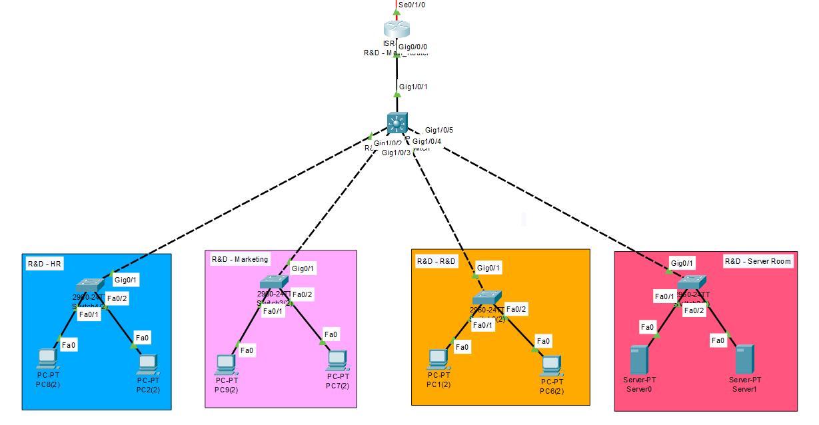
Figure 7: Structured Framework of our sketched design.

Layer 1 (Internal Layer)

2.3.1.1 Core Layer
This tier serves as the network's backbone, connecting to the distribution layer and enabling high-speed packet switching. It provides reliability, fault tolerance, and peak performance while minimizing CPU strain from security services, inspection, QoS classification, and other factors (Kumar, et al., 2014).

Distribution Layer
The Core Layer and the Access Layer are separated by this layer. Gathering data from the Access Layer and distributing it to the other network nodes is its main duty. It uses filtering and Access Control Lists (ACL) to achieve policy-based security. It also offers redundancy and load balancing.

Access Layer
The access layer connects end devices like computers and printers to the network. It supports services like QoS, Port Security, and ARP Inspection, handles Layer 2 switching, and protects the network from malicious attacks by securing endpoints (Fiber Optic Cabling Solutions, 2024).

Layer 2 (Data Link Layer)
The Data Link Layer is categorized as Layer 2 under the OSI (Open System Interconnection) network architecture paradigm. Its primary responsibility is to guarantee accurate information transfer. It can also encode and decode inputs and outputs of data. Two sublayers make up the Data Link Layer:
- Logical Link Control (LLC): This technology controls data transmission, including multiplexing, and provides problem notifications and network acknowledgments.
- Media Access Control (MAC): This system controls frame addresses, device user interfaces, and physical media accessibility.

Ethernet
Ethernet is the most common LAN technology, offering low-cost, flexible, and easy-to-manage cable-based data transfer. It uses twisted-pair copper and fibre optic cables, encapsulating data in frames. Gigabit Ethernet operates at 1 Gbps, while Fast Ethernet runs at 100 Mbps. (GeeksforGeeks, 2024).

VLAN
VLANs are logical networks that segment traffic for device groups within a physical LAN. They improve security, performance, and management. Static VLANs are simpler, while dynamic VLANs offer more flexibility and scalability. (WIKIPEDIA, 2024).

Layer 3 (Network Layer)
The network layer, the third layer in the OSI model, plays a crucial role in data transfer by ensuring data quality and controlling routing. It determines the best route for data packets and provides pathways for communication between devices, while also managing data transfer channels (CLOUDFLARE, 2023).

IP (Internet Protocol)
IP (Internet Protocol) manages data packet transfer between devices on the internet or other networks, uniquely identifying each device for routing. It works with protocols like TCP and UDP to ensure reliable communication. (WhatIsMyIPAddress, 2024).

Routing
Routing is the process used by Layer 3 devices to choose the most efficient path for data packets, ensuring reliable delivery by selecting the shortest route based on various criteria. There are three types of routing:
- Static Routing: human-created static routes that stay in the network until the administrator modifies them.
- Dynamic Routing: Routing protocols such as OSPF or BGP dynamically modify and manage routes based on network conditions.
- Default Routing: If there isn't another specific route established for the packet's destination, this route is made to forward any packet to that destination, which is frequently the gateway.
(GeeksforGeeks, 2024)

NAT (Network Address Translation)
Network Address Translation (NAT) converts local IP addresses to global ones, allowing multiple devices to share a public IP for internet access.
- Dynamic NAT: Employment of a range of public IP addresses, where it assigns one of them as required.
- PAT (Port Address Translation): The most common NAT, used in homes and small businesses, assigns multiple local IPs to a single public IP via different ports, also called NAT overload (CompTIA, 2024)

Tools of Choice

Routers

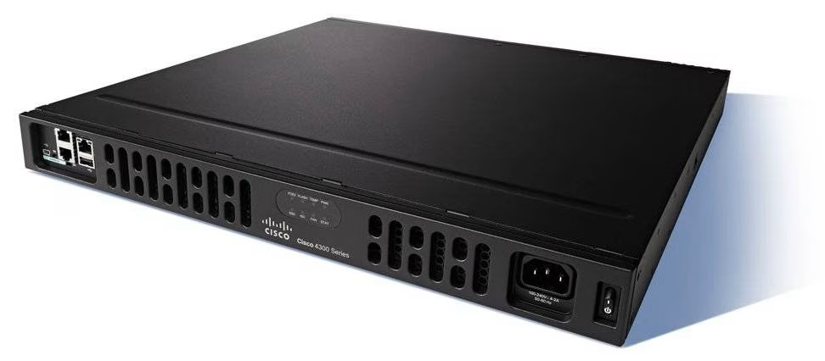
Cisco ISR 4331
Figure 8: Cisco 4331 Integrated Services Router.
Connecting to wide area networks is made dependable and extremely secure with the Cisco ISR 4331 router. To satisfy the demands of contemporary networking, it offers sophisticated features like VPNs, Quality of Service (QoS), and integrated security in addition to supporting extra interfaces like WAN.

Advantages of Cisco ISR 4331
- High Performance: Provides outstanding processing capacity to manage demanding applications and substantial amounts of data.
- Integrated Services: Minimizes the need for separate hardware by supporting cutting-edge services including firewall features, VPNs, and QoS.
- Scalability: The ability to accommodate new modules and updates as the company demands change.
(SecureITStore, 2024)

Disadvantages of Cisco ISR 4331
- Cost: Cost is higher upfront than entry-level routers, which might not be appropriate for small businesses.
- Complexity: Advanced features could call for qualified staff for configuration and management.

Cisco ISR 4321
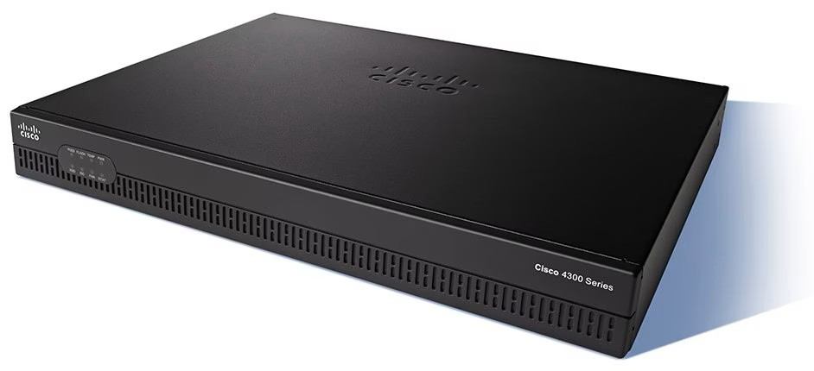
The Cisco ISR 4321 router offers reliable and secure WAN connectivity for small to medium-sized businesses, with features like VPNs, QoS, and integrated security. Its support for additional interfaces and high-speed connectivity makes it ideal for modern networking needs.

Figure 9: Cisco 4321 Integrated Services Router.

3.1.2.1 Advantages of Cisco ISR 4321
- High Performance: Up to 100 Mbps throughput, scalable for growing businesses.
- Energy Efficient: Reduces power consumption and operational costs.
- Reliability: Redundant power and failover features ensure high availability.

Disadvantages of Cisco ISR 4321
- Higher Cost: Compared to entry-level routers, the ISR 4321 can be expensive, especially when adding modular components.
- Complex Configuration: Requires technical expertise for advanced features like VPN, QoS, and SD-WAN setup.
- Limited Modular Slots: Only 2 onboard LAN ports and limited expansion slots, which may restrict scalability for some use cases.

Cisco 1941/K9
The Cisco 1941/K9 is a compact ISR ideal for small to medium-sized businesses, offering reliable WAN connectivity, security, and voice services. It supports VPN, QoS, and integrated threat protection for efficient networking.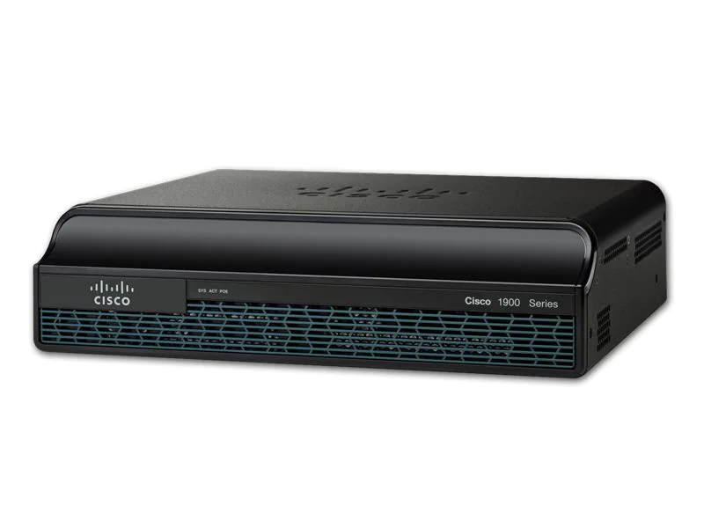
Figure 10: CISCO1941/K9 Cisco 1941 Router ISR G2.

Advantages of Cisco 1941/K9
- Compact and Affordable: Cost-effective solution for small businesses.
- Integrated Security: Supports VPN, firewall, and intrusion prevention.
- Voice and Data Integration: Ideal for VoIP and unified communication.

Disadvantages of Cisco 1941/K9
- Limited Performance: Lower throughput compared to newer models like the ISR 4000 series.
- Outdated Technology: Older hardware and software (Cisco IOS) with limited support for modern features.

Feature | Cisco ISR 4331 | Cisco ISR 4321 | Cisco 1941/K9
Form Factor | 1 RU | 1RU | Desktop/1RU
Integrated WAN Ports | 1 GE/SFP | 1 GE/SFP | 2GE
Performance | 100 Mbps (Upgradeable to 300 Mbps) | 50 Mbps (Upgradeable to 100 Mbps) | 25 Mbps
Default/Max Flash | 4 GB/16 GB | 4 GB/8 GB | 512 MB/2 GB
Redundant Power Supply | No | No | No
USB Ports (Type A) | 2 | 1 | 2
Scalability | High (Supports additional modules) | Moderate (Limited module support) | Low (Fixed configuration)
Table 1: Comparison of Key Features Across Cisco Routers (Router-switch.com, 2018).
The Cisco ISR 4331 stands out for its performance, scalability, and advanced features like QoS, WAN optimization, and integrated security. Its modular design and ability to handle high traffic make it ideal for medium to large organizations needing reliable, secure network infrastructure.

.

Switches

Cisco Switch Catalyst 3650
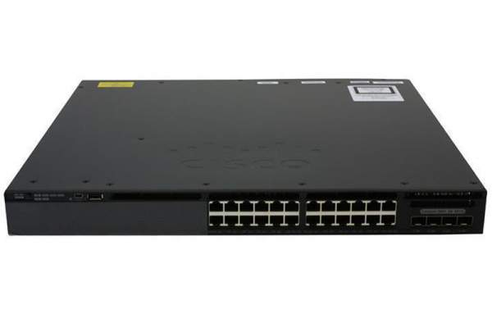
The Cisco Catalyst 3650 is a high-performance switch for branch offices and SMBs, offering Layer 3 routing, QoS, and robust security. With built-in wireless controller capabilities and stacking support, it provides reliable, scalable connectivity for modern networking needs.
Figure 11: Cisco Switch Catalyst 3650.

Advantages of Cisco Switch Catalyst 3650
- Scalability: allows for the smooth expansion of a network without sacrificing performance by supporting the stacking of several switches.
- High Performance: built with cutting-edge Layer 3 routing capabilities for gigabit speeds, guaranteeing effective data handling in demanding settings.
(SecureITStore, n.d.)

Disadvantages of Cisco Switch Catalyst 3650
• Higher Cost: The Catalyst 3650 is more expensive compared to entry-level switches, making it less ideal for smaller businesses with limited budgets.
• Complexity: Advanced features like Layer 3 routing, QoS, and wireless integration require a higher level of technical expertise to configure and manage effectively.

Cisco WS-C2960+24PC-S Switch
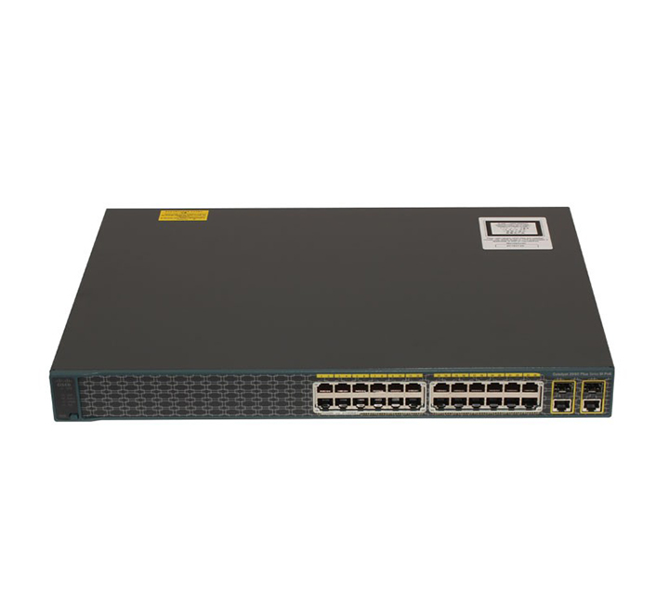
For small to medium networks, the Cisco WS-C2960+24PC-S Switch is a dependable Layer 2 switch with 24 Fast Ethernet PoE ports.

Figure 12: Cisco WS-C2960+24PC-S Switch.

Advantages of Cisco WS-C2960+24PC-S Switch
• Cost-Effective: Provides reliable performance at an affordable price, making it ideal for small to medium-sized networks.
• Easy Management: Simple to configure and manage with Cisco’s IOS software and tools like Cisco Network Assistant.

Disadvantages of Cisco WS-C2960+24PC-S Switch
• Limited to Layer 2 Functionality: Lacks advanced Layer 3 features like routing, limiting its use for larger or more complex networks.
• No Advanced PoE Features: Offers limited PoE power (up to 370W), which may not be sufficient for high-power devices.
Features | Cisco WS-C2960+24PC-S Switch | Cisco Catalyst 3650 (Layer 3)
PoE Support | 24 PoE ports, ideal for IP phones & access points. | PoE+ supports more power for higher-demand devices.
Layer 3 Capabilities | No Layer 3 routing (Layer 2 only) | Full Layer 3 routing, supports dynamic IP routing.
Cost-Effectiveness | Affordable for small to medium networks. | Higher cost but offers more advanced features and scalability.
Security Features | Basic security with port security, and ACLs. | Advanced security with ACLs, 802.1X, and trust boundaries.
Management | Easy management with Cisco IOS. | Advanced management with Cisco DNA, and full support for network automation.
Table 2: Comparison of Pros Between Cisco WS-C2960+24PC-S Switch and Cisco Catalyst 3650 (Layer 2 vs. Multilayer Switch) (CISCO, 2018)
The Cisco WS-C2960+24PC-S was chosen for its affordability, PoE support, and energy efficiency in small to medium networks. The Cisco Catalyst 3650 was selected for its advanced Layer 3 features, scalability, and security, making it ideal for larger, more complex networks. Together, these switches address the network's diverse needs.

Identifying and Addressing Security Vulnerabilities

Security is essential for everything that holds important data. Access to private information and data would be desired. Potential dangers include viruses, hackers, and even illegal access.

Switch Port Security
Switch port security functionality is its ability to support network security by regulating access to the network and preventing abuse of the network. It makes it possible for network managers to specify which machines are allowed on the network by filtering the connection based on MAC addresses. Therefore, this documentation analyses the concept of switch port security, its configuration procedures, and their significance in the network service provision.
Port security allows a Cisco switch to limit and identify MAC addresses of the devices that are permitted to access the port which in turn restricts input to an interface. When port security is configured, the switch will keep track of the MAC addresses used by the computers connected to the port and will stop new connections to the port if an unauthorized device is connected. This comes in handy in situations where new devices would like to connect to the network but are not permitted because of potential risks such as data theft, attacks, or unauthorized usage of resources.

Key Features
- Dynamically discovered and Static MAC Address: Some MAC addresses may be permitted to use the port, which is set as a security measure. The ports can be set with fixed addresses, or they can be configured to automatically learn. When a device operating under an unauthorized MAC address attempts to connect to the network the switch may block the traffic, deny access, or close the port, within the stipulations set by the violation mode.
- Sticky MAC Addresses: It means that with sticky MAC addresses, the switch dynamically learns, and stores MAC addresses connected to its ports. It stores the addresses in the configuration of the switch so that the same devices can always reconnect after a reboot, and no reconfiguration is required.
- Violation Modes: Port security supports three violation modes.
  - Protect: Drops packets from unauthorized MAC addresses without generating a security violation alert.
  - Restrict: Drops packets from unauthorized MAC addresses and increments the security violation counter.
  - Shutdown: Disables the port immediately upon detecting a security violation and sends an SNMP trap notification.
- Trunk and Access Port Support: Port security can be configured on access ports and trunk ports. Port security can be configured on trunk ports to protect MAC addresses on a per-VLAN basis, while on access ports, it protects MAC addresses on the access VLAN.
(Cisco Systems, Inc., 2015)
Feature/Configuration | Description | Example/Details
Port Security | Limits the number of MAC addresses on the switch port. | Only allows authorized devices to connect to the port.
MAC Address Limiting | Specifies the maximum number of MAC addresses allowed on a port. | switchport port-security maximum 2.
Static Secure MAC Addresses | Manually configures specific MAC addresses for the port. | EX: switchport port-security mac-address 00A1.B2C3.D4E5
Dynamic Secure MAC Addresses | Automatically learns and limits MAC addresses on the port based on connected devices. | Dynamically stores MAC addresses in the switch’s memory.
Sticky Secure MAC Addresses | Learns MAC addresses dynamically but saves them in the running configuration. | EX: switchport port-security mac-address sticky.
Violation Modes | Defines actions when a security violation occurs. | Options: Protect, Restrict, Shutdown
Protect Mode | Drops packets with unknown MAC addresses but does not log or send alerts. | Packets from unauthorized devices are silently dropped.
Restrict Mode | Drops packets from unauthorized MAC addresses and sends alerts via SNMP or logs them. | Logs a violation and increments the security violation counter.
Shutdown Mode | Shuts down the port if a security violation occurs (default mode). | The port is placed in the err-disabled state.
Recovery from Shutdown | Enables recovery for ports disabled by a security violation. | Example: errdisable recovery cause psecure-violation.
Table 3: Overview of Switch Port Security Features and Configurations

References
Amazon Web Services, 2024. What is WAN (Wide Area Network)?. [Online]
Available at: https://aws.amazon.com/what-is/wan/#:~:text=A%20wide%2Darea%20network%20(WAN,area%2C%20or%20even%20the%20world.
[Accessed 22 January 2025].
Cisco Systems, Inc., 2015. Port Security, San Jose: Cisco Systems, Inc..
CISCO, 2018. Cisco Catalyst 3650 Series Switches Data Sheet. [Online]
Available at: https://www.cisco.com/c/en/us/products/collateral/switches/catalyst-3650-series-switches/data_sheet-c78-729449.html
[Accessed 22 January 2025].
CISCO, n.d. CIsco. [Online]
Available at: https://search.cisco.com/search?query=routers&locale=enUS&bizcontext=&cat=&mode=text&clktyp=enter&autosuggest=false&istadisplayed=false&tareqid=&categoryvalue=
[Accessed 22 January 2025].
CLOUDFLARE, 2023. What is the network layer? | Network vs. Internet layer. [Online]
Available at: https://www.cloudflare.com/learning/network-layer/what-is-the-network-layer/
[Accessed 22 January 2025].
CompTIA, 2024. Network Address Translation Definition | How NAT Works. [Online]
Available at: https://www.comptia.org/content/guides/what-is-network-address-translation
[Accessed 22 January 2025].
Fiber Optic Cabling Solutions, 2024. What Is Access Layer and How to Choose the Right Access Switch?. [Online]
Available at: https://www.cables-solutions.com/what-is-access-layer-and-how-to-choose-the-right-access-switch-f4222-s3079.html
[Accessed 22 January 2025].
GeeksforGeeks, 2024. Advantages and Disadvantages of Bus Topology. [Online]
Available at: https://www.geeksforgeeks.org/advantages-and-disadvantages-of-bus-topology/?ref=header_outind
[Accessed 21 January 2025].
GeeksforGeeks, 2024. Advantages and Disadvantages of Tree Topology. [Online]
Available at: https://www.geeksforgeeks.org/advantages-and-disadvantages-of-tree-topology/?ref=header_outind
[Accessed 21 January 2025].
GeeksforGeeks, 2024. Hierarchical Network Design. [Online]
Available at: https://www.geeksforgeeks.org/hierarchical-network-design/
[Accessed 22 January 2025].
GeeksforGeeks, 2024. What is Ethernet?. [Online]
Available at: https://www.geeksforgeeks.org/what-is-ethernet/
[Accessed 22 January 2025].
GeeksforGeeks, 2024. What is Mesh Topology?. [Online]
Available at: https://www.geeksforgeeks.org/advantage-and-disadvantage-of-mesh-topology/
[Accessed 22 January 2025].
GeeksforGeeks, 2024. What is Routing?. [Online]
Available at: https://www.geeksforgeeks.org/what-is-routing/
[Accessed 22 January 2025].
GeeksforGeeks, 2024. What is Star Topology?. [Online]
Available at: https://www.geeksforgeeks.org/advantages-and-disadvantages-of-star-topology/
[Accessed 21 January 2025].
Javapoint, 2025. What is Tree Topology?. [Online]
Available at: https://www.javatpoint.com/what-is-tree-topology
[Accessed 21 January 2025].
Kumar, S., Dalal, S. & Dixit, V., 2014. THE OSI MODEL: OVERVIEW ON THE SEVEN LAYERS OF COMPUTER NETWORKS, s.l.: International Journal of Computer Science and Information Technology Research.
Montori, F., Bedogni, L., Felice, M. D. & Bononi, L., 2018. Machine-to-machine wireless communication technologies for the Internet of Things: Taxonomy, comparison and open issues.. Pervasive and Mobile Computing, Volume 50, pp. 56-81.
Mukherjee, A., Misra, S. & Raghuwanshi, N. S., 2019. A survey of unmanned aerial sensing solutions in precision agriculture. Journal of Network and Computer Applications, Volume 148, pp. 1084-8045.
Router-switch.com, 2018. Benefits of Migrating to Cisco ISR 4000 & Comparison of ISR 4000 Models. [Online]
Available at: https://www.router-switch.com/faq/migrate-to-isr4000-comparison-of-isr-4000-router.html
[Accessed 22 January 2025].
SecureITStore, 2024. Cisco Integrated Services Router 4331. [Online]
Available at: https://www.secureitstore.com/ISR-4331.asp
[Accessed 22 January 2025].
SecureITStore, n.d. Cisco Catalyst 3650 Standalone and Stackable 24-Port Switch. [Online]
Available at: https://www.secureitstore.com/C3650-24-L.asp#:~:text=The%20Cisco%20Catalyst%203650%20Series,productivity%20and%20reduce%20your%20TCO.
[Accessed 22 January 2025].
WhatIsMyIPAddress, 2024. Whats my IP address?. [Online]
Available at: https://whatismyipaddress.com/
[Accessed 22 January 2025].
WIKIPEDIA, 2024. VLAN. [Online]
Available at: https://en.wikipedia.org/wiki/VLAN
[Accessed 22 January 2025].

APPENDIX A- VLSM Plan & Topology

VLSM Plan
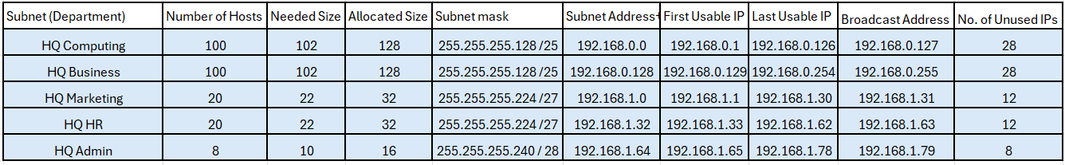
Main Campus
Figure 13: Screenshot of a VLSM of the Main Campus

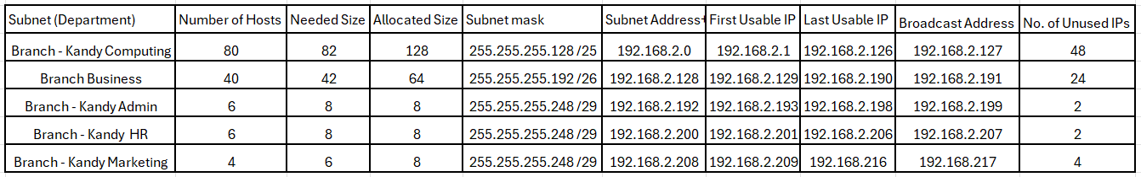
Kandy Branch
Figure 14: Screenshot of a VLSM of the Kandy Branch

Research & Development
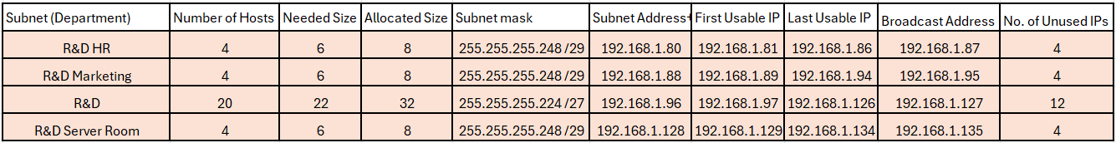
Figure 15: Screenshot of a VLSM of the R&D

Topology
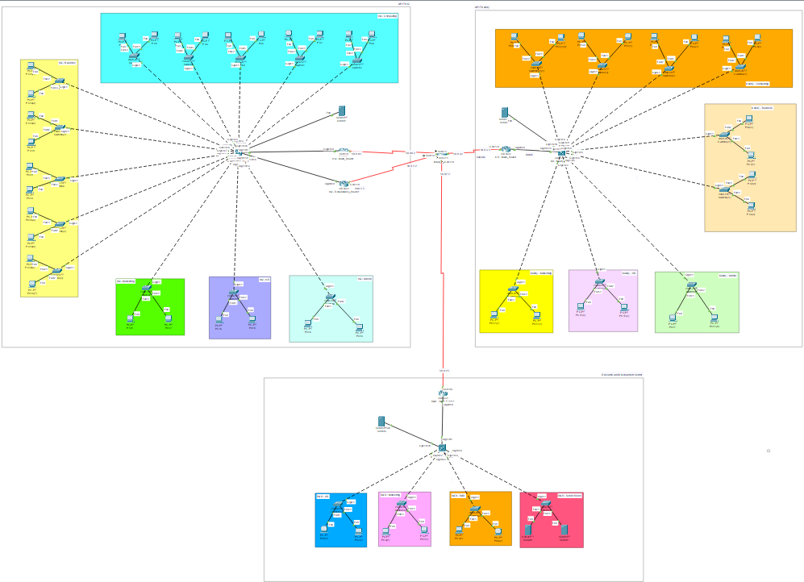

Figure 16: The entire Topology.

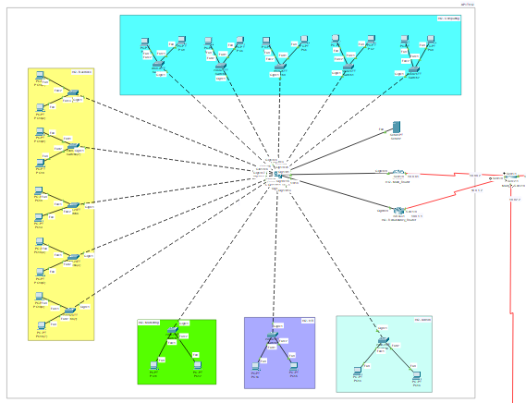

Figure 17: Topology of the Main Campus.

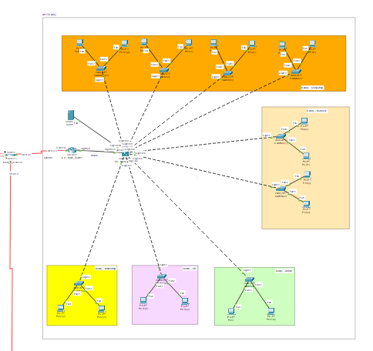

Figure 18: Topology of the Kandy Branch.

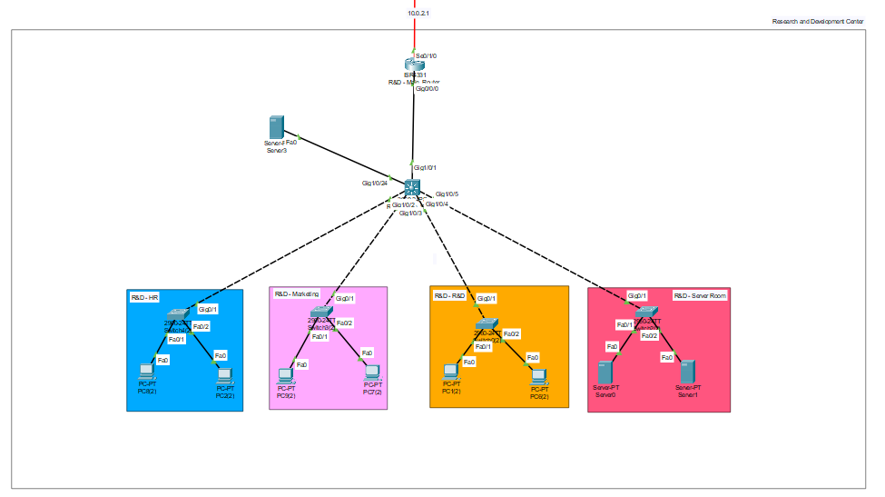

Figure 19: Topology of the R&D.

Configurations

Vlanning
The below screenshots show the configuration of a VLAN and a VLAN brief.

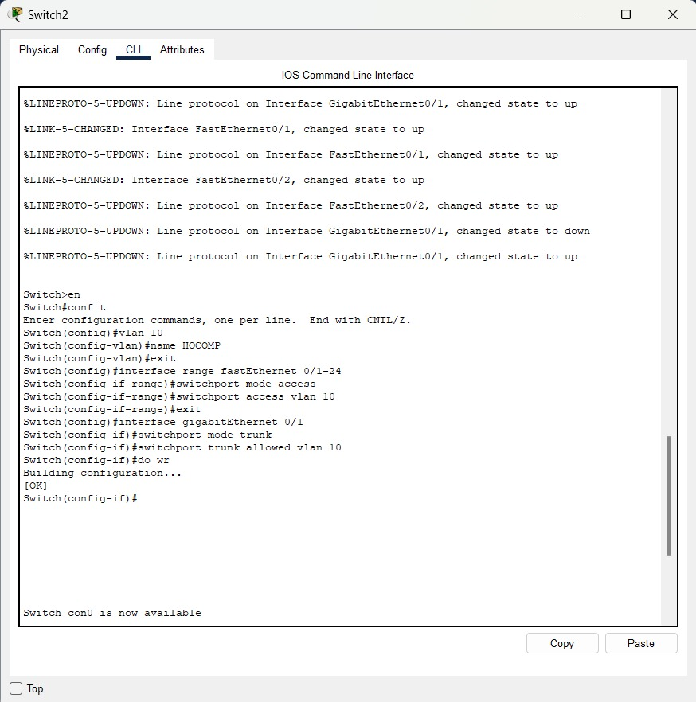
Figure 20: Configuration of a VLAN in the Main Campus.

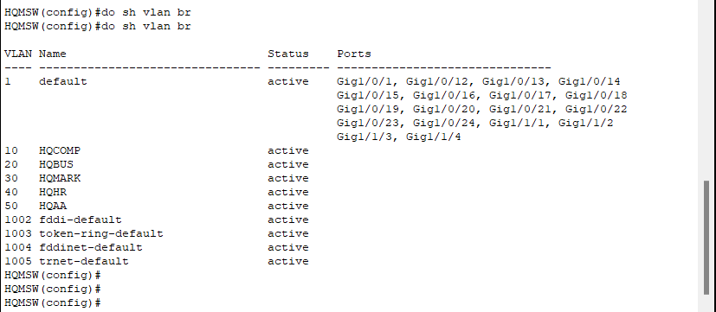
Figure 21: A screenshot of a VLAN brief.

Figure 20 diagrams Switch 2 of the Computer Department in the Main Campus in terms of its VLAN configuration. It entails creating VLAN 10 (HQCOMP) and assigning FastEthernet 0/1 through 24 as access ports in VLAN 10. Included in consideration, too, is a configuration of a GigabitEthernet 0/1, a trunk port with acceptance of a specific VLAN 10, to allow for inter-switch communications for VLAN 10. With such a configuration, FastEthernet-connected machines will fall under the HQCOMP VLAN, and the trunk port will allow for inter-switch communications for VLAN 10.
The VLAN brief of the Main Campus is seen in Figure 21, generated through a “do show vlan brief” command. All VLANS that have been configured, including default VLAN 1, and VLAN 10 (HQCOMP) and other VLANS such as HQBUS (20), HQMARK (30), HQHR (40), and HQAA (50), have been included in the output. Included in output, too, is a mapping of a specific VLAN to a specific port, such as VLAN 10 (HQCOMP) for Gig1/1/3 and Gig1/1/4 and VLAN 1 (default) for several such as numerous ports including Gig1/0/1 and Gig1/0/12-24. In its summary, a general view of VLANS and respective mappings for individual ports for the whole of the Main Campus network is generated.

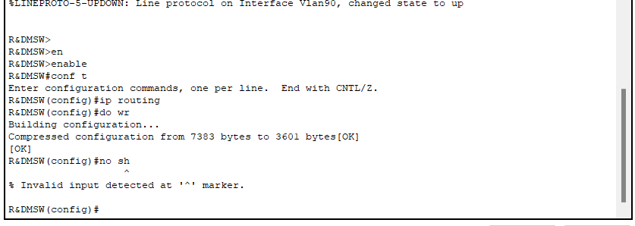
IP Routing
Figure 22: A Screenshot of an Enabling IP Routing on the R&D Switch.
Figure 22 shows a screenshot of an IP routing configuration for the R&D switch. First, we enter privileged EXEC mode using the "enable" command. Next, we enter global configuration mode using the "configure terminal" command. In that mode, we enable routing for IP using the "ip routing" command, and the switch can then route between networks or VLANS at Layer 3 level. After enabling routing for IP, we save the configuration using the "do write" command to make the configuration persistent even in case of a reboot.

WAN
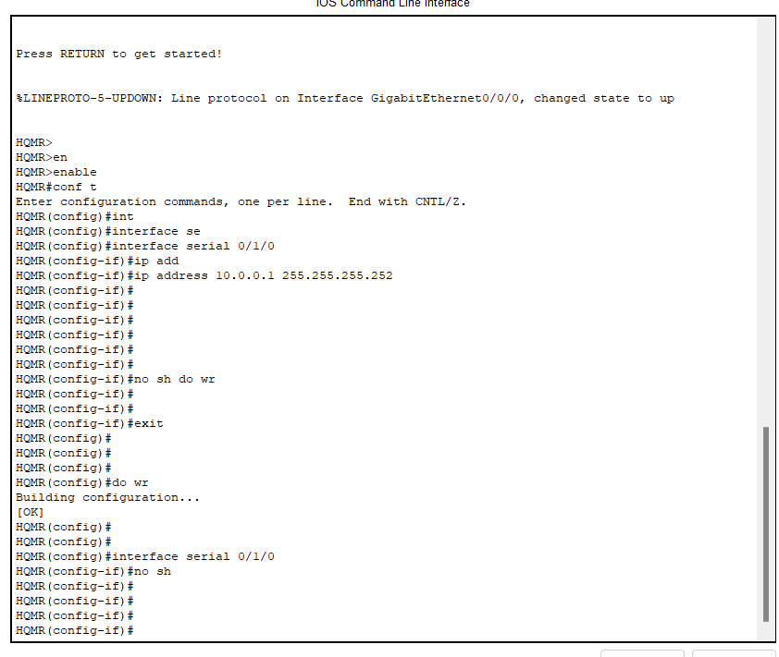

Figure 23: Configuring Serial Interface on the Main Campus’s Marketing Department Router.
In Figure 23, we show a configuration for the serial interface of an HQMR router. First, we press the RETURN key to begin initializing the router and then enter privileged EXEC mode with an "enable" command. Next, we enter the global configuration mode with a "configure terminal" command.
Then we configured the serial interface 0/1/0 by entering an interface configuration mode with an "interface serial 0/1/0" command. We assign an IP address to an interface with an "ip address 10.0.0.1 255.255.255.252" command, assigning an IP and a subnet mask. After assigning an IP address, we enable an interface with a "no shutdown" command and save configuration with a "do write" command to save configuration even in case of a reboot.

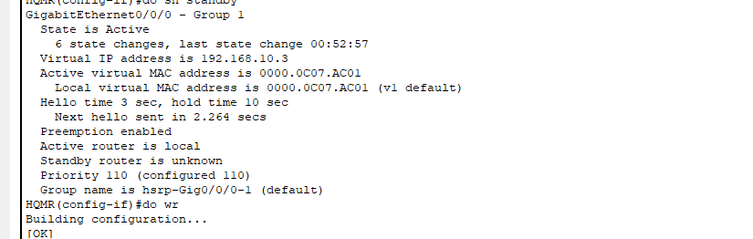
HSRP
Figure 24: Configuring HSRP for High Availability on HQMR router.
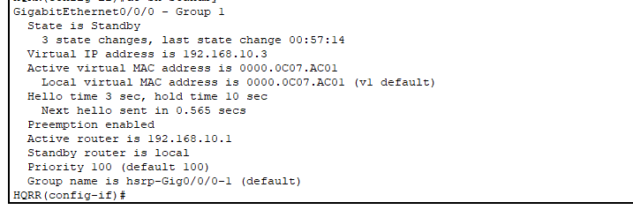
In Figure 24, we configure HSRP in the HQMR router to make the network highly reliable. On the GigabitEthernet0/0/0, HSRP Group 1 is defined with a virtual IP address value of 192.168.10.3. As an active router, a value of 110 is given for the HQMR router to prefer its traffic for the group. Preemption is enabled, and the router can reacquire its role as an active router in case it fails and then reenters online. We save our configuration with the "do write" command to make settings persistent.
Figure 25: Configuring HSRP for High Availability on HQRR Router.

In Figure 25, HSRP group 1 is designed in the HQRR (Redundancy Router). The HSRP router for the HQRR is set with a default value of 100 and is a standby router. The same virtual IP address (192.168.10.3) is shared to maintain uniformity in the group. HSRP router for the HQRR will track the active router (HQMR) and will become active when the active router fails, offering transparent failure and high availability for the network.

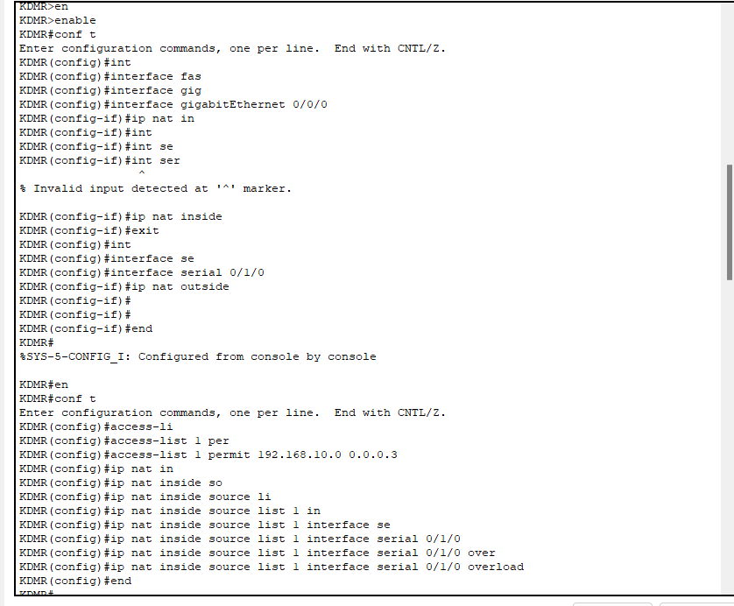
NAT
Figure 26: Configuring NAT on the KDMR Router.
In Figure 26, We demonstrate how to set up the KDMR router's Network Address Translation (NAT). First, we enter global configuration mode and use the command "ip nat inside" to declare that the GigabitEthernet 0/0/0 will be an inside NAT interface.
Next, we make a statement that Serial 0/1/0 will be an outside NAT interface with the command "ip nat outside". With such a configuration, the router can convert private IP addresses in an inside network to a public IP address in the outside network.

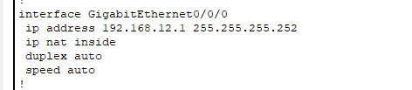
Figure 27: A screenshot of an inside NAT interface.

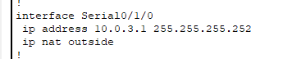
Figure 28: A screenshot of an outside NAT interface.
In Figure 27, we confirm the configuration of the inside NAT interface (GigabitEthernet 0/0/0), with an IP address of 192.168.12.1 and the "ip nat inside" configuration. In Figure 28, we confirm the configuration of the outside NAT interface (Serial 0/1/0), with an IP address of 10.0.3.1 and "ip nat outside" configuration.

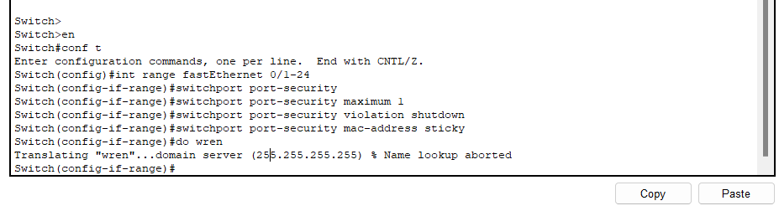
Switch Port Security
Figure 29: A screenshot of a configuring Port Security on the Switch.
We show the configuration of port security on the switch in Figure 29. We enable port security on FastEthernet 0/1 through 24 interfaces with the "switchport port-security" command in global configuration mode. We specify that in a security violation, the port will shut down, and we specify a maximum of 1 secure MAC address. We use the "switchport port-security mac-address sticky" command to enable sticky MAC address learning, allowing the switch to dynamically learn and store the MAC addresses of attached devices.
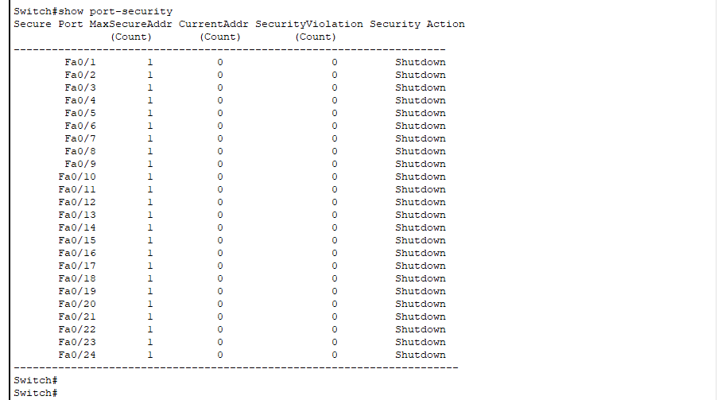
Figure 30: A screenshot of a verifying Port Security on the Switch.
By printing out the configuration of the switch, we can confirm the port security settings in Figure 30. With VLAN 10 assigned to each FastEthernet 0/1-5 interface and sticky MAC address learning, we can confirm in output that port security is enabled.
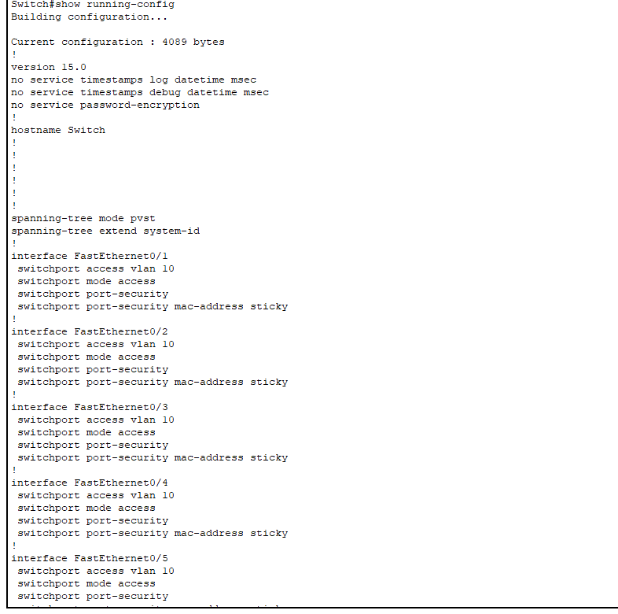
Figure 31: A screenshot of a verifying Port Security on the Switch.
The "show port-security" command in Figure 31 is used to confirm other port security settings. One secure MAC address per port for all FastEthernet 0/1-24 interfaces, as in the output, is acceptable. There have been no security violations, and security violation action is disabled for all interfaces.

Redundancy
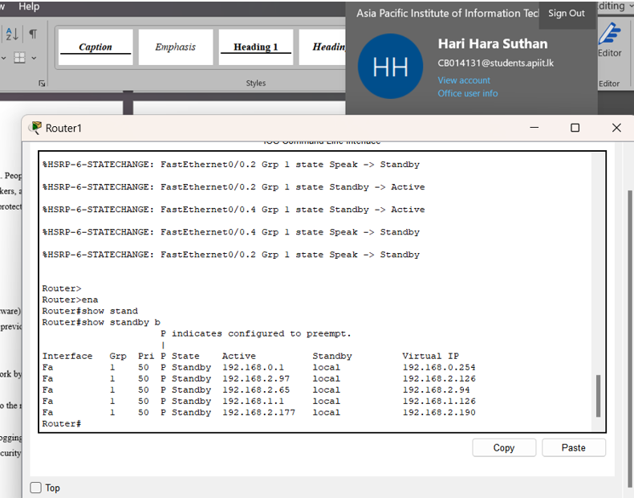
Figure 32: Monitoring Redundancy and Failover on Router.
In Figure 32, we’re keeping an eye on the state changes happening on the Router, which plays a key role in our network’s redundancy setup. The output reveals several transitions for groups on the FastEthernet0/0.2 and FastEthernet0/0.4 interfaces. For instance, Group 1 on FastEthernet0/0.2 shifts from Speak to Standby and then to Active, signaling that Router is stepping up as the active device for this group. In the same way, Group 1 on FastEthernet0/0.4 goes from Standby to Active, so Router1 is now processing traffic for this group. These state changes highlight the redundancy that is built into the network. This redundancy also means that if the primary device goes down, the Router can easily step in and take over, providing uninterrupted connectivity to the network.

